Project Initialization and Planning Phase

Date | 21-sep-2026
Team ID | Master of Computer Applications
Project Name | Online Learning Engagement and Student Performance Analysis
Maximum Marks | 3 Marks

Define Problem Statements (Student Problem Statement Template):

A student problem statement describes a real challenge from the student's point of view: who they are, what they are trying to achieve, what gets in the way, why it happens and how it makes them feel. For the Online Learning Engagement and Student Performance Analysis project, the students are the instructors, student-support advisers, programmers managers and learners of an online learning programmer. The problem statements below are based on the Power BI analysis of 22,422 students and define what the dashboards must show so that low engagement, dropout risk and gaps in performance can be spotted and acted on early.

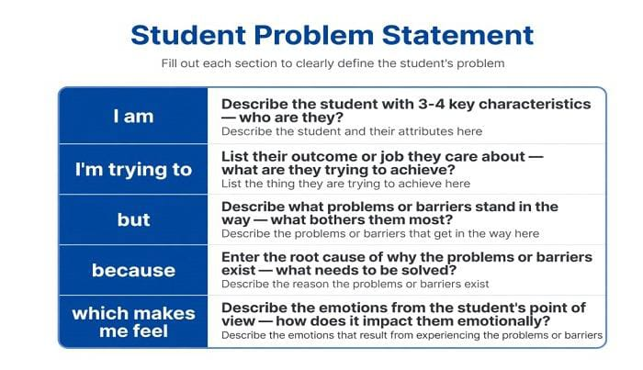

Problem Context (from the Power BI analysis):
- 22,422 students are spread across three engagement levels: Medium (37.46%), High (33.95%) and Low (28.59%), so about two-thirds of learners are not highly engaged.
- Engagement is linked to results: high-engagement students fail or withdraw about half as often as students overall (about 22% versus roughly 40%).
- 10,691 students (about 48%) are at High or Very High risk of failing or dropping out.
- Prior education shapes outcomes: students with no formal qualifications show about 28% dropout and about 42% pass rate, compared with about 18% and 67% for post-graduates.
- Region is not the differentiator: average scores are roughly 71–75 in all 13 regions.

Problem Statements:

Problem Statement (PS) | I am (Customer) | I’m trying to | But | Because | Which makes me feel
PS-1 | A course instructor at an online learning provider | Spot students who are losing interest early and keep them on track to finish the course | 28.59% of students (6,410) are at Low engagement and 37.46% more are at Medium, so many struggle without anyone noticing | Activity data such as clicks is not linked to results in one view, so warning signs are seen too late | Worried and reactive, because I only see the problem after students fail or withdraw
PS-2 | A student-support adviser | Focus my limited time on the learners most likely to drop out | About 48% of students (10,691) are at High or Very High risk, which is too many to support one by one | There is no simple way to filter risk by education, gender, region and engagement to pick priority groups | Overwhelmed and unsure where to start
PS-3 | A learner with no formal qualifications, studying online | Keep up with the course and pass it | Learners like me drop out at about 28% and pass at only about 42%, against about 18% and 67% for post-graduates | I have little prior study experience and receive little guidance matched to my starting point | Anxious and discouraged, as if I am more likely to fail
PS-4 | A programme manager responsible for online learning outcomes | Decide where to invest support and resources fairly across regions and student groups | Average scores are almost the same in all 13 regions (roughly 71–75), so region does not show who needs help | The real gaps lie in engagement, prior education and risk level, which a regional view hides | Uncertain about where extra effort will make the biggest difference

